

MODULE 8: ASSIGNMENT: JSON PRACTICE

ELVIA GISELLA ADAIR
STUDENT

LATONYA LEWIS
TEACHER

NOVEMBER 23, 2025
ASSIGNMENT: JSON PRACTICE

Create a program that includes the following:
- Use the JSON load() function to load the file into a Python class list.
- Create a function that loops through the .json class list and prints out each value, should look something like:
  - Ripley, Ellen : ID = 45604 , Email = eripley@gmail.com
- Output notification to the user that this is the original Student list.
- Call your print function.
- Add your last name, first name, fictional ID, and email to the class list using append().

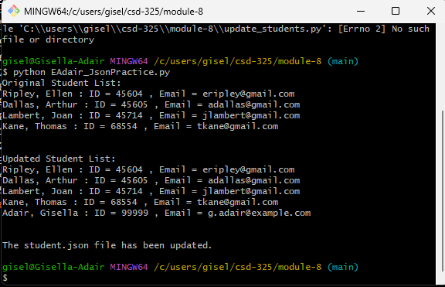

- Output notification to the user that this is the updated Student list.
- Call your print function.
- Use the JSON dump() function to append the new data to the .json file.
- Output notification to the user that the .json file was updated.
- Run the program and take a screenshot of the results. Paste that screenshot into your Word document.
- Once the program runs, you should also see a notification that the student.json file has changed, with a choice to save or not.
- I did not get any notification

- Open the .json file and copy the contents, then paste that into your Word document.

